

TOPIC: ADVANCED WEB
NAME: NATASHA WANJIRU
ADM NO: BSCCS/2024/53895
COURSE: BACHELOR OF SCIENCE IN INFORMATION TECHNOLOGY
DEPARTMENT: COMPUTING AND INFORMATICS
UNIT CODE: BIT3208
UNIT NAME: ADVANCED WEB DEVELOPMENT
DEPARTMENT: COMPUTING AND INFORMATICS
ACADEMIC YEAR:3.2
LECTURER: MR NYORO
SUBMISSION DATE: 05/06/2026

GITHUB REPOSITORY:

TABLE OF CONTENTS.
WEEK 1: Environment Setup. 2
Step 1: Install Localhost Tools. 2
Step 2: Test Localhost Successfully. 3
Step 3: Create Hello World Pages. 4
Step 4: Test Basic Database Connectivity. 5
WEEK 2: Wireframes, GUI Design and Project Planning. 6
Step 1: Design Wireframes. 6
Step 2: Design GUI Layouts. 9

WEEK 1: Environment Setup.
The goal of Week 1 was to set up a local development environment (localhost) so PHP scripts and databases can be tested on your own computer without internet hosting.

Step 1: Install Localhost Tools.
Figure 1.1: Shows that xampp installed.
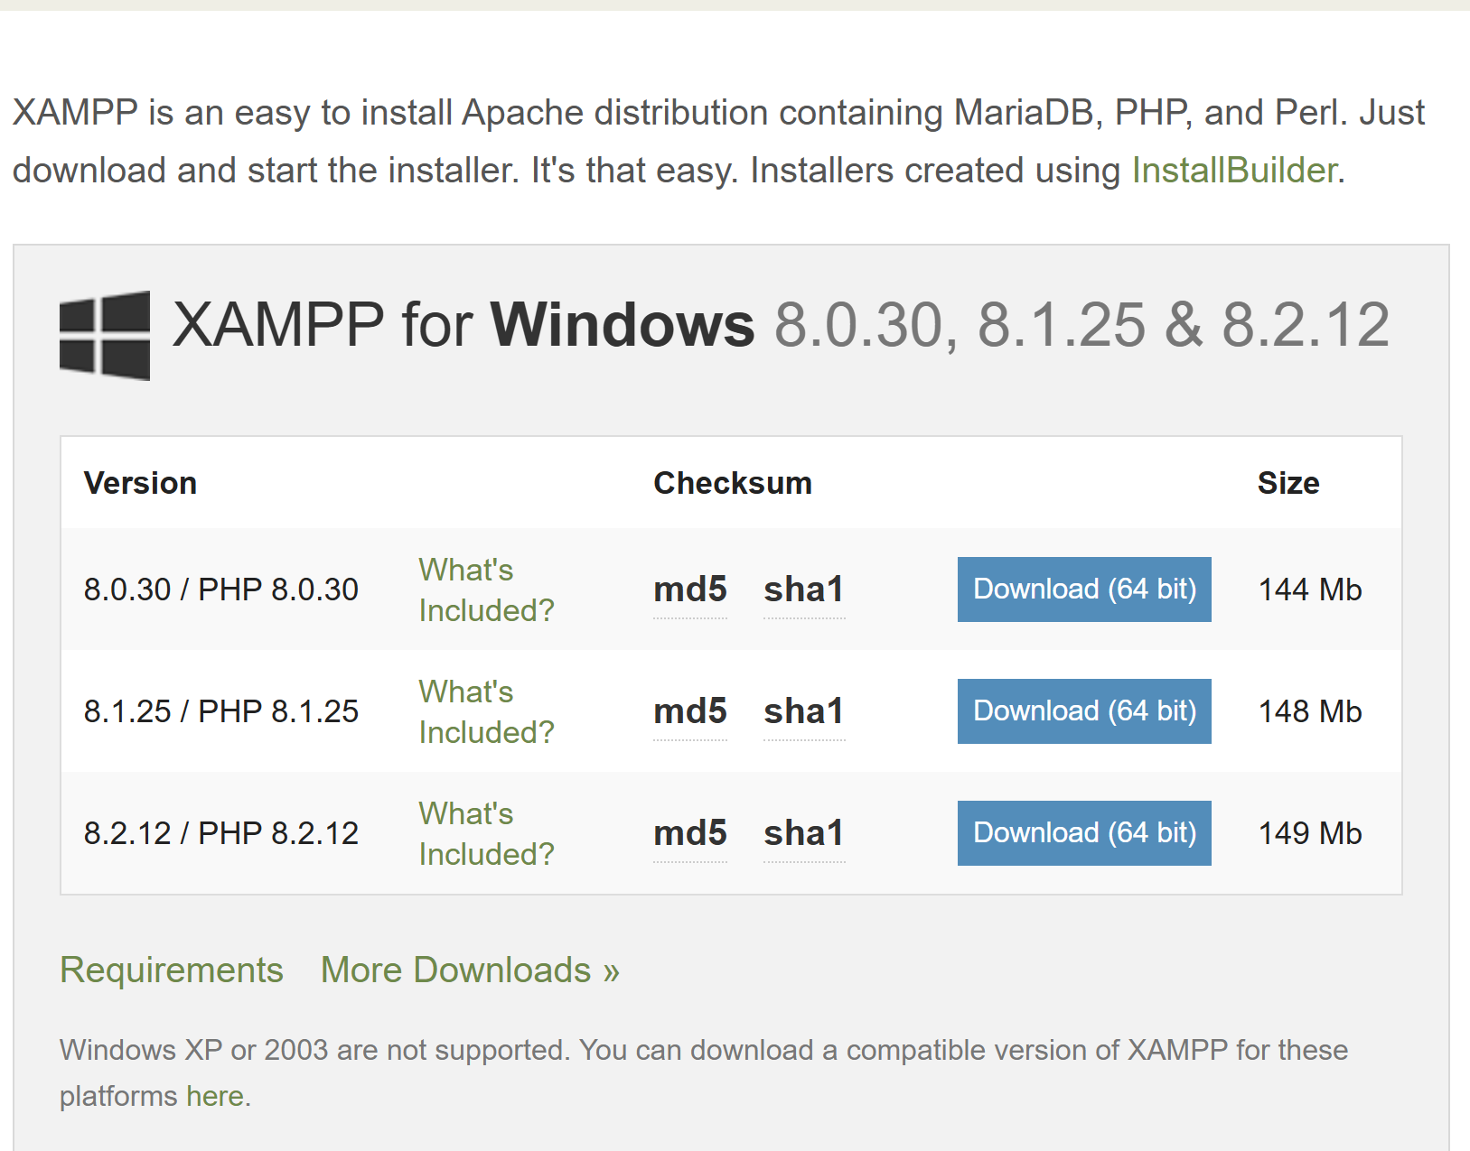

Step 2: Test Localhost Successfully.
Figure 1.2: Shows that xampp is successfully installed.
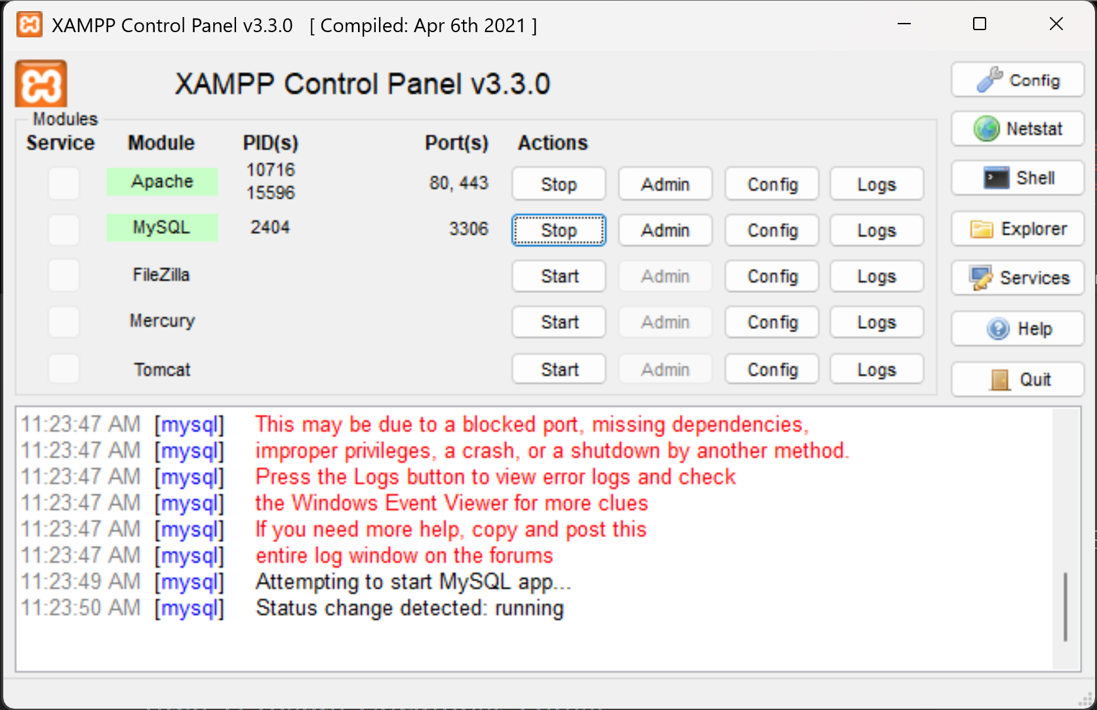

Figure 1.3: Shows that xampp is working successfully.
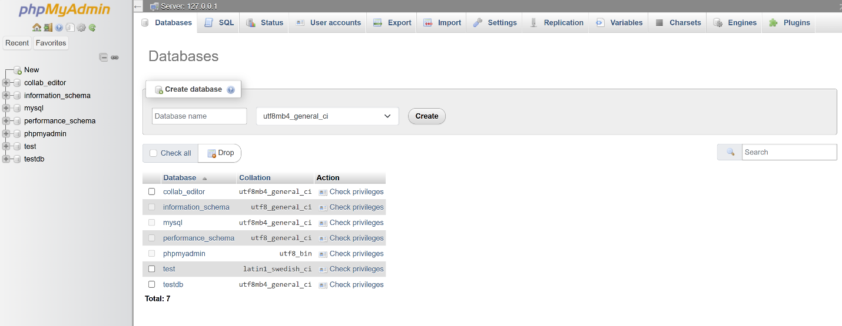

Step 3: Create Hello World Pages.
Figure 1.4: Shows the Hello World page created with php.
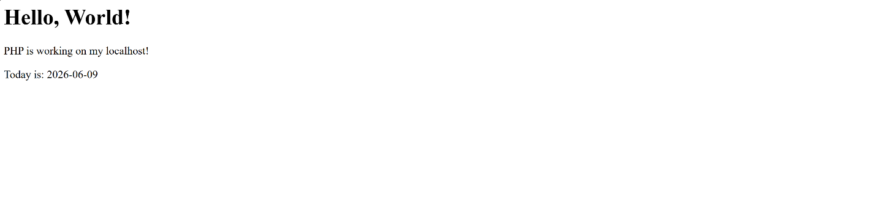

Figure 1.5: Shows the Hello World page created with html.
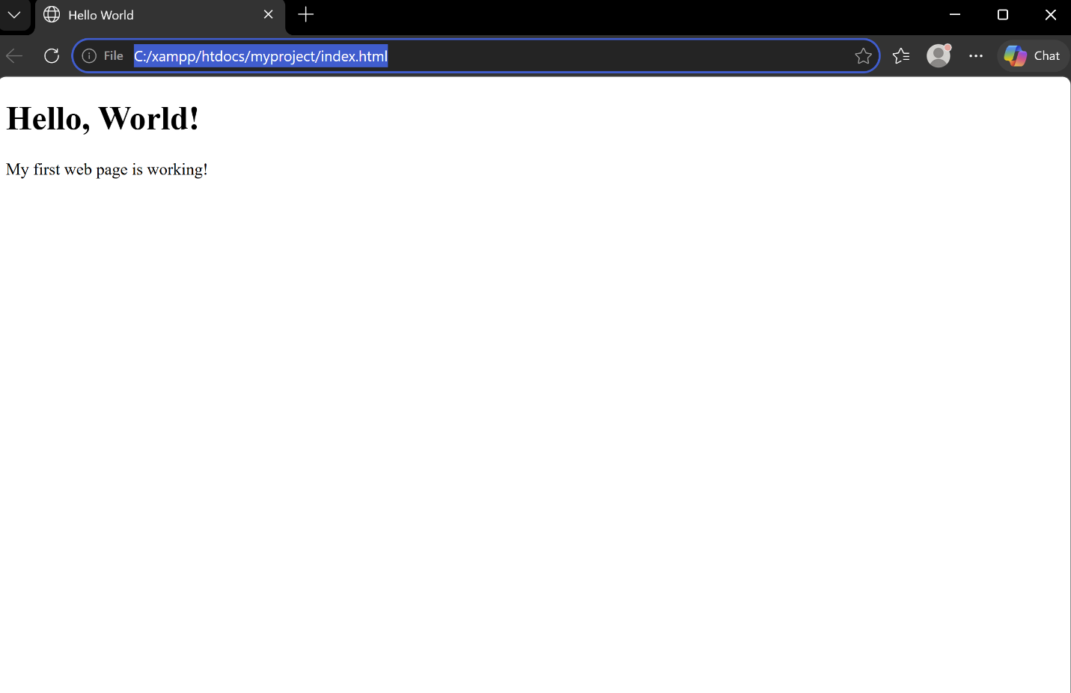

Step 4: Test Basic Database Connectivity.
Figure 1.6: Shows the basic database connectivity.
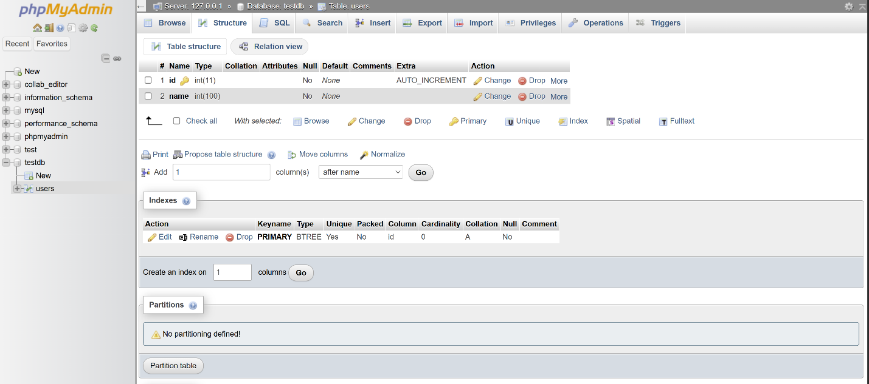
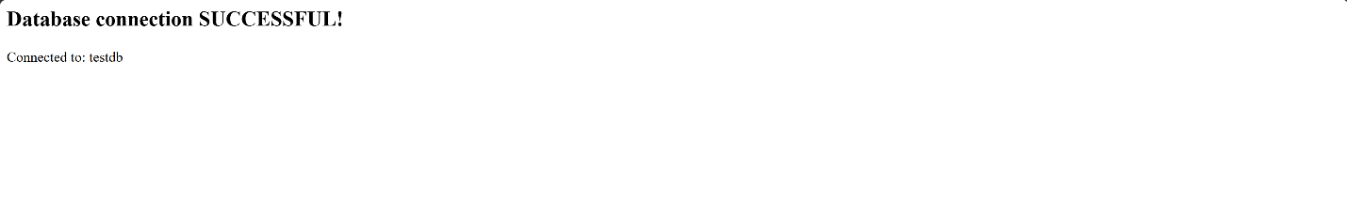

WEEK 2: Wireframes, GUI Design and Project Planning.
Week 2 focuses on planning your project before writing any code. This is an important professional habit — developers always plan the layout and flow before building.

Step 1: Design Wireframes.
Figure 2.1: Shows the first page ( Homepage ) of the wireframe.
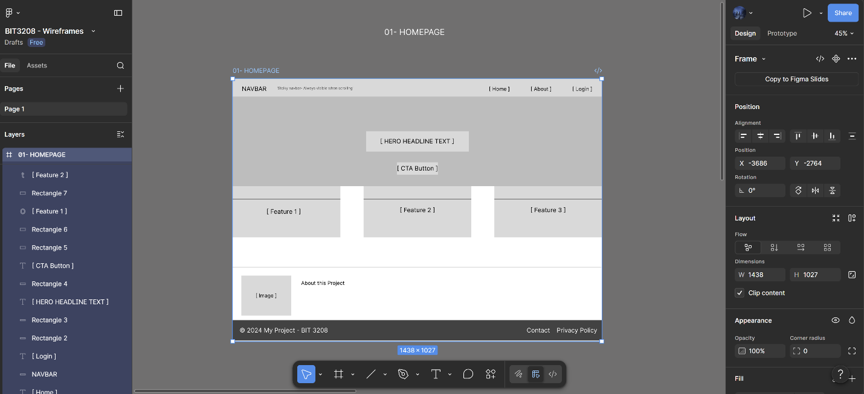
Figure 2.2: Shows the second page( login page ) of the wireframe.
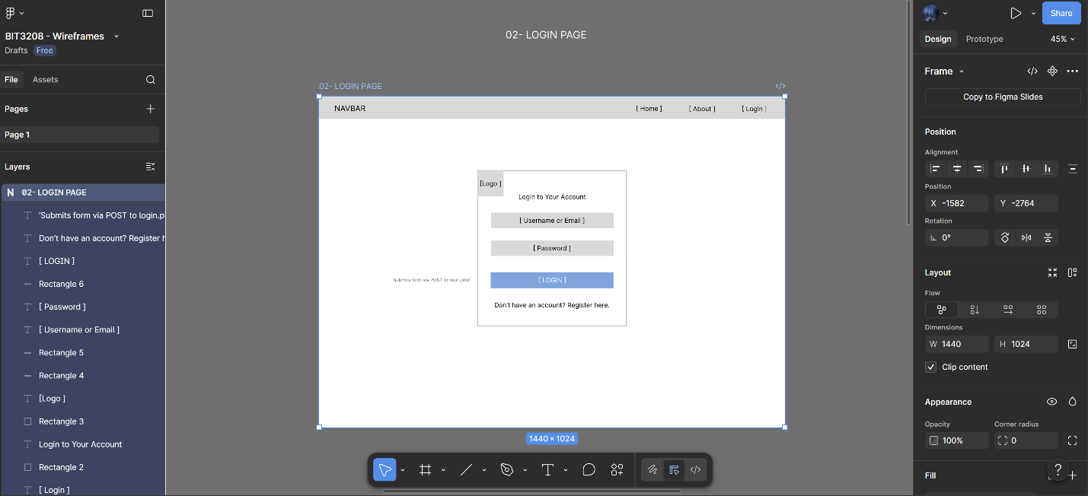
Figure 2.3: Shows the third page ( Registration page ) of the wireframe.
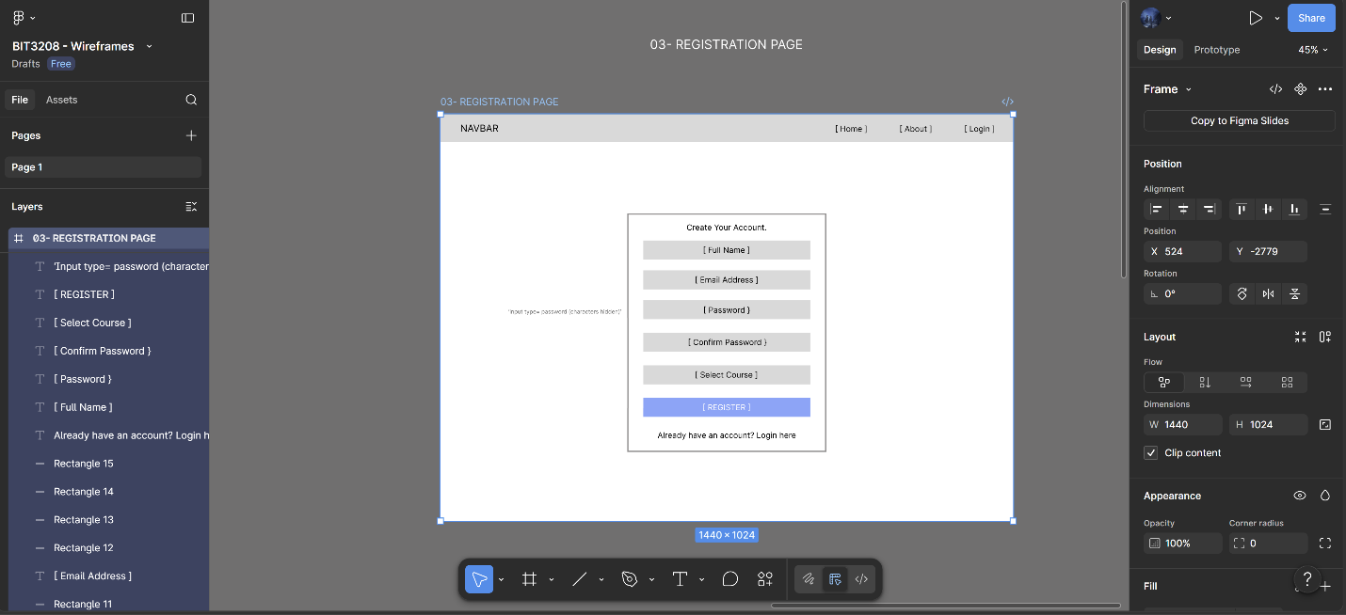
Figure 2.4: Shows the fourth page ( Dashboard ) of the wireframe.
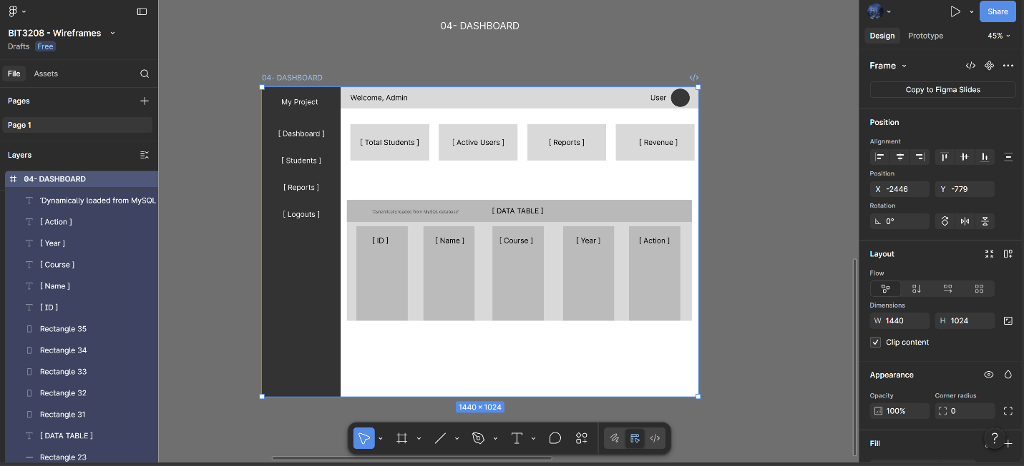
Figure 2.5: Shows the fifth page ( Contact Page ) of the wireframe.
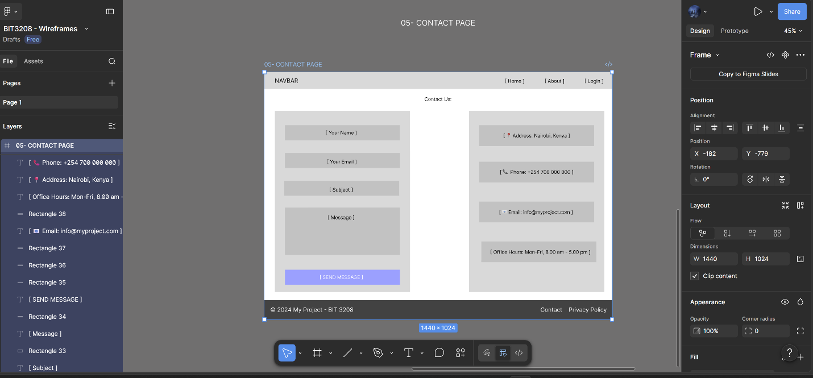

Step 2: Design GUI Layouts.
Figure 2.6: Shows the output in a browser.
